NHB+ Market Positions

Mindset

- I”ve always been fascinated by the difference between people
- Why is that some achieve so much, yet others not much at all?
  - How can Elon make $300b and someone struggles to make $300 a week?
- A lot of the difference is the identity
  - Who are they?
  - Identity is a culmination of all of your belief systems working together from the past present and FUTURE
    - If you didn’t, you’d never think about them
- The language in itself is VERY limiting, so we are limited to what we can understand if the primary method of understanding is limited in itself.
  - The reason it’s limited is because we use words to describe either words
  - If we have to use words to describe words, then we can never truly grasp what the thing is
- 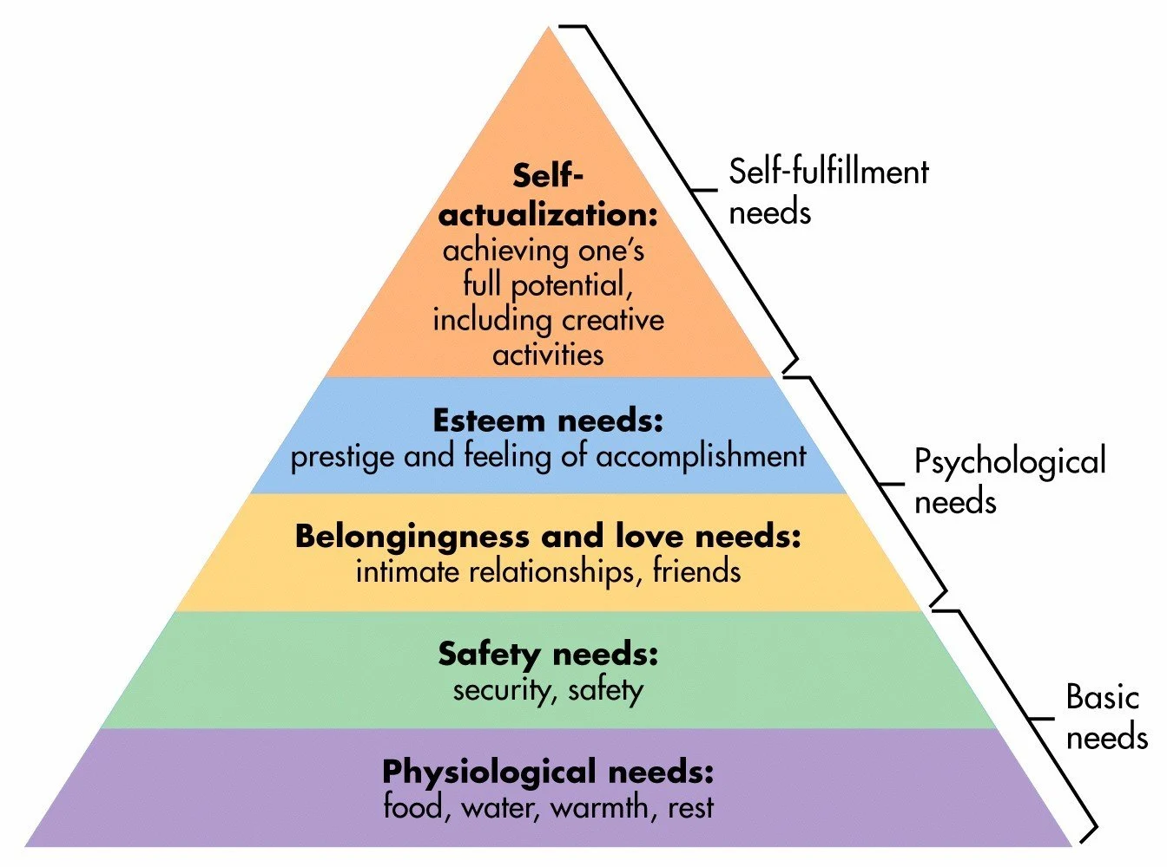
- Self actualization = what are you talking about?
- So if you change self actualization to “identify” it makes sense
- “A belief system”
  - “A safety system”
    - All beliefs are there to keep you safe
    - If all beliefs are there to keep you safe, then all a belief system is really a “safety system”
- What does EVERY safety system have to have in order to function properly?
  - Rules
  - Certainty
  - Boundaries
  - Expectations
  - Consequences
- So when you “change beliefs”, you’re really “changing safety system components” = do they feel safer with this or with that.
  - This is why “risk reversal works”
  - If a belief system wasn’t a safety system, then we would not need to read amazon reviews, need money back guarantees, sociology wouldn’t work, branding wouldn’t exist, etc…
    - “safety system”

- What does EVERY safety system have to have in order to function properly?
  - Rules
  - Certainty
  - Boundaries
  - Expectations
  - Consequences
  - It needs a governor or a controller. It needs a kill switch that cause the system to STOP.
  - FEAR
  - What are threats to the safety system?
    - What’s the biggest threat?
      - CHANGE
- So super successful people have better “safety systems” than others.
- The least successful people I know are the most risk averse.
  - Change = risk
  - No change = no risk
  - No change = things stay the same
  - You can’t grow?
- If fear is the regulator, then we have to change fear itself.
  - In order to change anything else, we must change fear itself.
- I was looking at buying other houses, and to do that I have to spend a lot of time in the future, because that purchase happens in the future.
- Fear being the governor of belief system (safety system)
  - It does not exist in the past
  - We can not be afraid of the past, try it.
  - If you are afraid of the past, then the only reason for being so is that you think that it will happen AGAIN in the future.
- Why can’t you be afraid of the past?
  - Because you have 100% certainty, there is ZERO uncertainty in the past.
- Fear can not exist in the past, so it must exist somewhere else? Mostly in the future
- As belief systems are safety systems, what does a safety system need in order to be very efficient?
  - Certainty
- And what is the 2nd most important thing for a safety system to have?
  - Control
  - If you have control = you feel good
  - “Take control” “take back control”
- If you think about the future that much, how much control do you really have of it?
  - You don’t have control over it and because you don’t have much control over it, therefore you have what? MASSIVE UNCERTAINTY
  - What comes out of massive uncertainty and lack of control? Fear
- What’s important to me right now? And what’s important tot me in the next 30 days, 60 days, 90 days? Things I have control over?
- When you do this
  - You can deal with a lot more in the present
- What if = any future thoughts are energy draining.
- Where I got this is about Tom Cruise being the most present man ever, and he has a ton of energy.
- The more in the future you are
- The less mental energy you have to expand today
- Because you are trying to control that which you cannot control
- All fear is in the future so the more you are in the future the more fear you have
- The key is to focus all your energy in the next 30 or so days
- That you can handle and you’ll get more done than you can even imagine
- If you watch Tyson here
- https://www.tiktok.com/t/ZPRveTC8H/
- He focused all energy in the next 3 minutes
- A lot of the issues you have are about who you are in the future. That’s where a lot of your energy burn goes.
- Limiting belief = over active safety system. Why is it over active? Because you lack the capability to protect yourself.
- If you haven’t achieved what you want, then by default you have a limiting belief and thus an over active safety system that’s keeping you from achieving it!
  - Then the question becomes…what do you lose when you make $100k a month?
    - Why do I choose the question of LOSS…because the safety system operates on NOT wanting to LOSE more than GAIN.
- Most limitations have double binds or triple binds
  - If I make more -> I can’t enjoy the life
  - If I want to enjoy the life -> I can’t make more

NHB+ Market Positions

- https://finance.yahoo.com/news/goose-lays-more-golden-eggs-113000690.html?guccounter=1
- But the Oracle of Omaha believes one of the reasons why the economic system might not work for young people today may come down to the market simply becoming more specialized and niche — which in turn widens the wealth gap and leaves more folks in the dust.
- “We’re in an economy where specialized talents bring incredible sums,” Buffett told CNN back in 2016, in response to a question regarding a study from Harvard University published that year on growing anti-capitalism sentiments in young adults.
  - Joshua made $350k at 21 years old
    - “Home school drop out”
  - Doctor makes 300k a year, Lawyer 150-200k
- “If you're a little bit where you really don't fit as well into the market system, you are left behind.”
- For example, the top 10% of households by wealth boast $7 million on average and collectively hold 69% of America’s total household wealth, according to St. Louis Fed data.
  - Specialized talent
- In comparison, the bottom 50% held around $51,000 on average per household, adding up to just 2.5% of the total household wealth.
  - Generalized talent
- Economy is all about “trade offs”
  - Supply and demand control prices
  - If you’re specialized, hard to replace ya, gotta pay you
  - If you’re generalized, easy to replace ya, don’t gotta pay you
- Strategy & Tactics
- Tactics live in strategies, so always knowing strategy is key
- Strategy changes the tactics
- But in order to know what strategy to use, you have to know where the market is at any given time
- If you know how things play out, then you’ll know what hands to play.
- I always focus on competing on economics, because all business exists within an ecosystem, so economics are the highest point of change
- If you study market economics, then you can detect all the changes taking place
- So the internet as a whole is not growing, but the other side, which is the production side is growing.
  - Things are growing WITHIN the internet
  - And because things are growing within the internet, they are causing a lot of change
  - For some, this change is welcomed, for others its a bad sign
  - If welcome, you can take advantage of it, if not, then it will take an advantage of you
- So the consumption side is NOT growing
- The production side is growing.
- When you have many consumers, but very few producers, the sales process can be hidden, products last longer, recurring lasts longer, easier to cut through the noise.
- When this switches around, everything becomes more difficult
- Consumption is tied to two resources:
- Time
- Money, what we spend money on is controlled by the amount of time I have to enjoy it
- If you’re doing organic, time is limited. So engagement goes down.
- If you're selling stuff, and they buy a bunch of stuff, money becomes limited.
- So in any mature market, limitations increase.
- As more people come into recurring, the more money is being extracted from every angle.
- That means that they will fatigue out faster.
- There is no infinite recurring, other than utility. Power, phone, internet, that are base functions for everything else.
- The best recurring strategy is to get out of recurring by getting money up front.
- A recurring program with a repeatable process becomes highly inefficient due to lack of reason to stay.
- So we’ll enter a catalog model.
- As more and more people come into the space, the consumer doesn't know who to trust, who to believe, who to follow, who to learn from, etc…

Why - problem stage
What & how - process stage in terms of categories
- Facebook ads
  - 3 guys
- Google ads
  - 2 guys
- Copywriting
  - 3 guys
- Etc….
- If you go back 5 years, you only had a handful in each category
- After you go to 7 people, then it switches to who stage
Who stage - who do I learn from and who do I work with? This answer is going to determine who takes about 80% of the money in the market

This is self evident in many fields

In the what / how stage - market positions are created.

- Market birth: Why - problem stag
- Market maturation: What & how - process stage in terms of categories
  - What do I need to do? And HOW do I do it?
    - They look at WHAT others are doing and they want to do it too, and then they don’t know how to do it.
  - Which leads to WHO the guy or girl?

Positions | Who’s occupying that position
- Copywriter position  - Biz op op  - Womens  - Skin Care  - Health  - Finance  - Offer architects  - Low Ticket  - Facebook ads  - Google Ads  - CRO  - CMO  - Email  - Quiz Funnels  - Upsells  - Downsells  - Bumps  - Checkout pages  - Book a call  - Webinars  - Phone Sales  - Follow up  - Customer services  - Ops  - Sales people  - Launches  - Challenges  - 10 Minute VSLs  - Catalog Model  - Influencer back ends | #12 phone sales - Cole Gordon  Most money in that segment  #3 - Perry Marshall - Google Guy  #17 - Jeff Walker - launch guy  #18 - Challenges - Pedro

Whoever takes the position, money goes to the 1st, and they don’t have to go chase it. Whereas, those who do not, they have to go chase the deals.

There is much less price resistance.

What happens is, most people will look at the guru, and they can not see the position.

You can look at Cole Gordon, but you can’t SEE that he’s taking a position.

The position Cole occupies is one of NEED. I need sales people, I need sales systems. The ONLY thing I care about is who can deliver on that.

It’s fighting for position in the marketplace.

Whoever holds the position, holds the $$$.

Once you hold the position, you don’t have to prove yourself to anyone

So the whole game is about getting, capturing and holding the position.

The position is a signal of STATUS

The 4 core drivers = status, security, reproduction and survival

There are positions and people
People could not occupy positions if there were no positions.

So the question becomes, how do you take someone's position?

They will NEVER give it to you, EVER…they will fight you for it.

The best way to hold the position is to not respond to the person.

So most will not respond, because the attack isn’t worth responding to.

Once you secure the position, you can make money from that position for about 10 years.

That’s how long it takes for the market entropy to deteriorate you before you get kicked off of it.

Low level marketing is played by non position takers.
The high game is taking positions.

There’s a table in the industry and you’ll never get invited to it, unless you have access to audiences.

This applies to all markets, there is a hierarchy that applies to all humans.

You take a market position by creating a problem with what they do, by asking a question that the answer is self destructive.

With market assumptions, we don’t scale products, we scale problems.

Each one of these positions is a FUNCTION in the marketplace.

What I mean by function is, you have to know how to run FB ads to get customers.

Or you need to learn how to sell high-ticket if you want a high ticket program.

Questioning its function in the marketplace

A question is the start of change

Challenge the relevance via time or skills

Challenge what they do, their skills set, their methodology and everything else.

And make them irrelevant.

You NEVER EVER EVER EVER attack them as people.

Don’t do character assassinations.

Convert them from competitors to supporters.

Listen to: hardcore history - the wrath of the khans

In fact, if you don’t ever name them it would be better, but EVERYONE will know who you’re talking about.

The way you do that is by putting them in the past.

When you put something in the past you automatically date it and it’s expired. No longer relevant.

Why does putting things in the past work so well? Because the ONLY constant in the universe is CHANGE.

So when you put it in the past, you generate a QUESTION, you automatically turn this into a problem.

The problem is, it no longer works.

If you can’t put it in the past, then dismantle it mathematically.

Or you want to move that into the future…and then say, that would be great IF, they had so and so.

The people in the present do not have the resources.

So Grant Cardone, I can put his stuff in the past easy because the interest rates have changed.

Or what I can do is put him in the future.

Grant, this thing is wonderful…IF your audience had $2m to play and RISK investing in RE because of high interest rates.

So all you’re doing is REMOVING IT FROM THE PRESENT, BECAUSE THE POSITION IS ONLY RELEVANT IN THE PRESENT.

So to make it IRRELEVANT it has to go somewhere, which is the past or the future.

You are in the present and explain why your stuff works in the present.

When it’s explained in the present, the brain will not search for any solutions or see problems. All problems are in the future.

And you and the customer go together in the future.

They leave with you into the future.

So if you have to remain in the present, then you want to put a heavy energy load on them in the present.

So I did this with the group's people by saying…groups are great, if you want to xyz, blah blah.

What happens is when someone takes the position, they take it by their methodology, skills, charm, resources, etc…

You always want to give a little love.

Webinars are GREAT if you can pitch, have a 20k back end, etc…

Because there is always someone making it work, and you gotta create difference and distance between them and that person.

You have to give love to it because a lot of people's safety is tied into it.

You want other people to stimulate buyers, when they stimulate buyers, it doens’ mean that they’ll BUY.

They just become MORE LIKELY to buy, and then they’re more likely to buy your stuff as the one who holds the position.

I use “before and after” language, because that is the language of change.

Before | What event caused the change  If you can explain this, and they understand it, they will trust you. | After
- Before tinder  - Before FB pixel change  - Before there were too many copywriters  - Before there was a million offers  - Before Google Slap  - Before Trump  - Before Obama  Here’s what happened here, and why it worked.  There is something here that made it work, you focus on this being no longer functioning.  FB pixel, economy, dating apps, number of people in the market, prices of things, interest rates, etc…  How old they are, their bodies changing | This is the event that puts them in the past.  You’re not putting them in the past, this EVENT is.  And this event is related to sensory experience that they can not say is NOT TRUE.  Here’s what happened, that it no longer works. XYZ factors are not the same any more, so therefore it can not be the same.  Since it can not be the same, it’s no longer available which means it’s no longer useful to get the outcome, so it’s no longer relevant. | - After tinder  - After FB pixel change  - After there were too many copywriters  - After there was a million offers  - After Google Slap  - After Trump  - After Obama  Here is what replaces that to allow sit to work even better than before.  Just so happens that we are the only ones who know this, have this, can do this, etc…and we can teach for $$$.

And a clear marketer that has created change.

Examples

Go a level ABOVE the thing they do that forces the thing to change.

Event change models

- Production / Consumption
- Supply / Demand
- Cause / Effect

Relevance is always PRESENT. All outcomes are in the future. All gain is in the future.

You can talk about specific people, the entire industry, everything.

The easiest people to take down are process driven people.

The offers that scale are all process driven.

Change the conversation to control the market.

Position
Person
Idea
- Let the best idea win, and then prove why other ideas are no longer relevant. The person who the idea is creating will fade away.
- For example: The idea of a high ticket webinar, consulting is what gave life to Sam Ovens, now since that idea no longer works, Ssam has become irrelevant.
  - To newcomers, he’s totally irrelevant
  - To older times he’s somewhat irrelevant
- What’s interesting about this point of view is that it’s not the person that matters, it’s the idea, because the person is a vehicle for the idea.
- In music, do we listen to Drake because it’s Drake, or is it because it’s the SONG? WE listen to the song, and he’s the vehicle for the song.
  - Once the songs are no longer good, he’s no longer good.
- The idea gives life to the market, and when the idea is gone, there is no more life in the market.
- The capability to execute the idea, makes the idea real.
- If the market loses capability, the idea is no longer valid.

Attack the idea,, the idea feeds the person, then the person goes down.

Another way you do this is by saying

“I used to do that until about 2015 then I stopped. The reason is I realized [change point]”

For womens side, you don’t want to ATTACK as much as you want to make them AWARE

The reason people hold on to ideas is because ideas give them security and status

So when you challenge an idea, you give them MORE security and status and the new idea will take hold and they’ll let go of the old.

Security is measured in their ability to predict the future.

The more you can put it in the past, the less predictable the future is going to be.

Attacking the identity is also a real pain.

Marketing is all about standing out and standing out is differentiation, you have to take the position and be different, better than the others.

